# Setting up lasers

Once fluorophores and virtual samples have been defined, lasers should be set up. You can define as many lasers as you want.

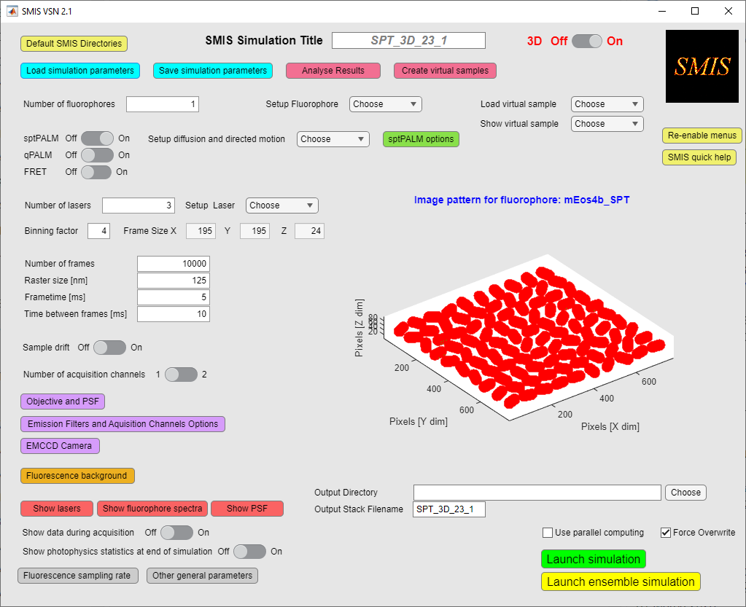

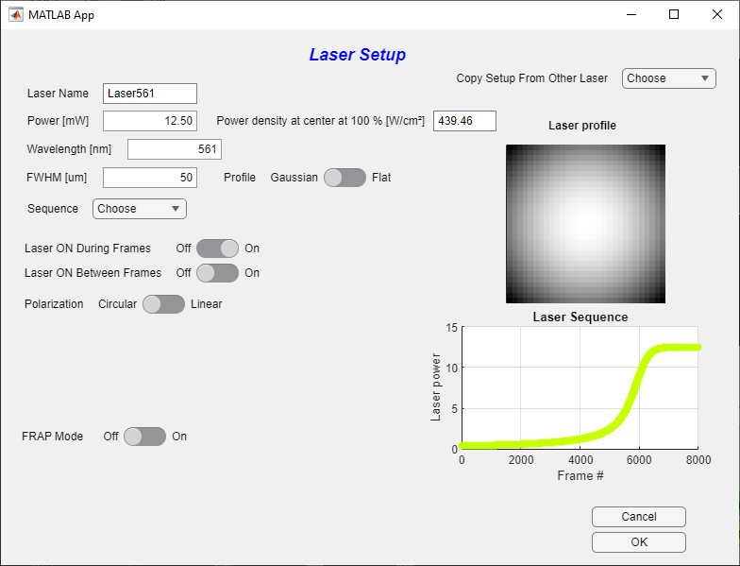To set up a laser, use « *Setup laser* » in the main SMIS window. You’ll get the following window:

**11**

**10**

**9**

**8**

**7**

**6**

**5**

**4**

**3**

**2**

**1**

1. Give a laser name (usually containing the chosen wavelength)
2. **Choose the laser power, or the laser power density at beam center. These 2 values are related, depending on the beam shape as defined in 4. and 5.   
   A virtual sample has to be loaded to get the power density. (This is because the virtual samples define the image size).
3. Choose the wavelengths. The color of the laser sequence plot will match the chosen wavelength.
4. Choose the type of profile: Flat or Gaussian beam.
5. Choose the width of the beam
6. Choose the laser sequence along that acquisition (see below for examples). The currently used laser sequence is shown on the plot on the lower right of the window.   
   **For some specific laser sequences (e.g. Fermi profile) which are dependent on number of frames in the acquisition stack, the sequence might be automatically reset if you happen to change the number of frames after you define a sequence.
7. Decide whether the laser is *on* during frame time
8. Decide whether the laser is *on* in between frames. You can only do that if the time between frames defined in the main SMIS window is > 0
9. **Set laser polarization. The laser can have circular or linear polarization. If linear polarization is chosen, define the angle of the laser polarization relative to the X axis of the focal plane. Laser polarization is only relevant when the option of anisotropic fluorophore dipole orientation is chosen for at least one fluorophore.
10. 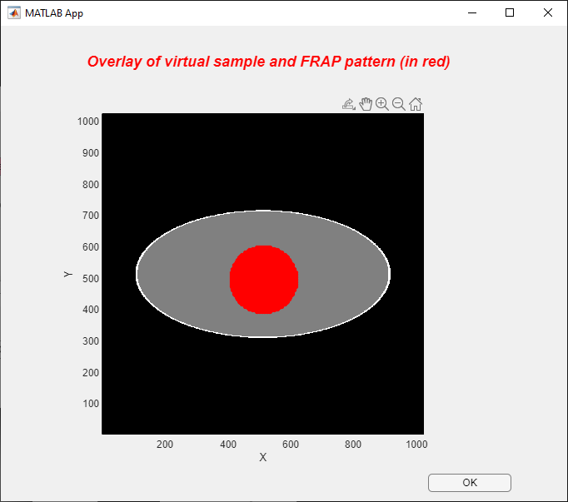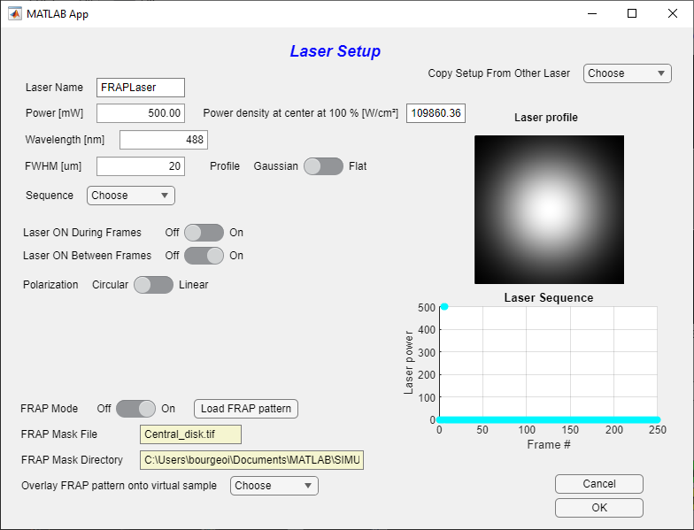**Lasers can be used in a “FRAP mode”. This means that the laser will only be applied in a restricted field of view defined by the FRAP pattern to be loaded. This is useful to simulate FRAP or pulse-chase experiments.   
    The FRAP pattern image must be an image of the same dimension as the camera image size defined in the main SMIS window.  
      
      
    To make sure, the FRAP pattern is correctly positioned on your virtual sample, use « *Overlay FRAP pattern onto virtual sample* »
11. You can copy all parameters from another defined laser to the current laser. This is in particular useful when you want to delete some lasers and only keep some that are at the end of the list: in that case copy the setting of the lasers you want to keep to those of the first lasers in the list.
12. 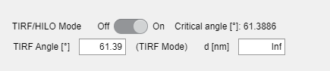In 3D mode, you have the option to use lasers in HILO or TIRF mode  
      
      
    Depending on the angle that you enter (lower or higher than the critical angle corresponding to the objective specifications (see « *Objective and PSF* » from the main SMIS menu), shown on the window), the TIRF or HILO mode will be selected. The characteristic depth *d* probed by the laser beam is then shown. Alternatively, you can change this characteristic depth, and the angle will be set accordingly.

## Lasers sequences

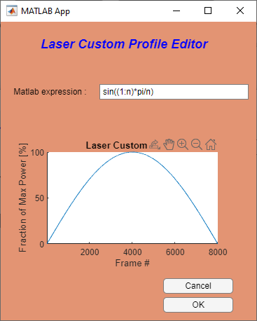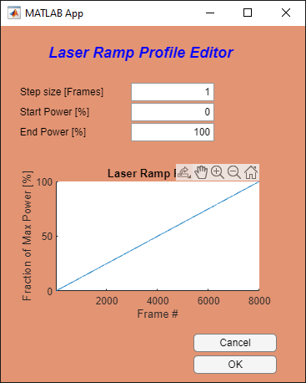Various types of laser sequences (evolution of laser power along data acquisition) can be entered. Three are shown below:

For the custom laser profile editor, a mathematical expression in Matlab format has to be entered. In this expression *n* is the number of frames.   
For example, to get a single pulse at frame number 4 (e.g. for a FRAP experiment), use:

*(1:n)>3 & (1:n)<=4.*

# Setting up Objective and PSF

Upon selecting « *Objective and PSF*» in the main SMIS window, the following window will appear:

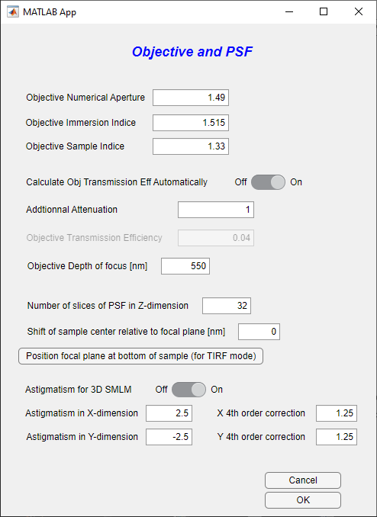

**In 3D**

**11**

**10**

**9**

**8**

**7**

**6**

**5**

**4**

**3**

**2**

**1**

1. You can enter the objective numerical aperture
2. The immersion medium refraction index
3. The sample medium refraction index
4. You can either set the objective transmission efficiency manually, or automatically calculate it based on the formula of Fourkas, 2001, Opt.Letters which is recommended.
5. In the latter case, you can add an additional attenuation that takes into account the additional losses due to filters, etc. The total microscope transmission efficiency will then be the automatically calculated number multiplied by the additional attenuation.
6. In the former case, enter the total transmission efficiency of the microscope.  
     
   The rest of the menu only appears in 3D mode
7. You can set the objective depth of focus
8. This number basically will define the resolution of the 3D PSF that will be calculated. The higher the number, the more accurate but the more computing time.
9. This defines the positioning of the virtual sample relative to the focal plane of the objective. If set to zero, the center of the virtual sample in the Z dimension is put at the focal plane.
10. Yes this to set the focal plane at the bottom of the sample so that its bottom surface is in focus, which is what is wanted for TIRF imaging notably.
11. Use this switch to perform 3D imaging via astigmatism. In that case, you have to define the extent of astigmatism as well as the fourth order corrections in the X and Y dimensions

# Setting up Emission Filters and Acquisition Channels

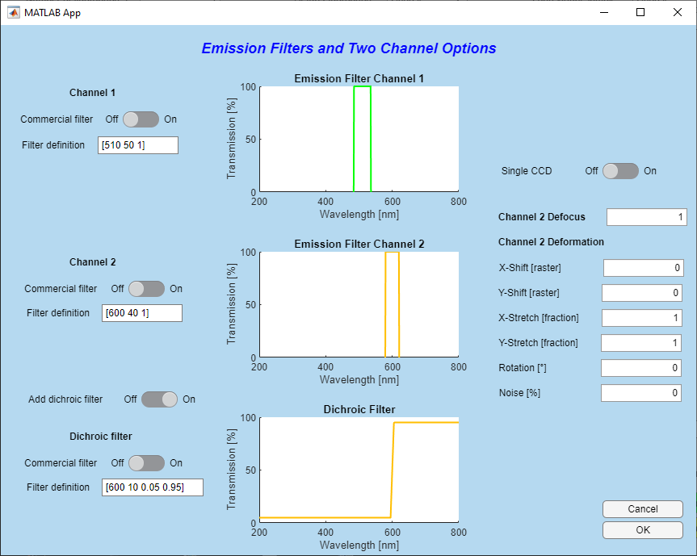Upon selecting « *Emission Filters and Acquisition Channels Options* » in the main SMIS window, the following window will appear:

**In dual channel mode**

**8**

**7**

**6**

**2**

**1**

**5**

**4**

**3**

1. An emission filter for channel 1 can be defined here. If a commercial filter definition is not used (2.), then use Matlab format to define emission filter. You can define for example a single band filter: e.g. [500 540 0.8] where 500 nm is the low-limit wavelength, 540 nm is the high-limit wavelength and 0.8 is the filter transmission. You can also use the format: e.g. [520 40 0.8] where 520 nm is the central wavelength, 40 nm is the bandpass and 0.8 is the filter transmission. To define a long pass filter use e.g. [700 inf 0.6]. You can also define multiband filters using e.g. , for a dual band filter [[500 540 0.8]; [700 40 0.6]].   
     
   **Importantly, you can check how your defined filter fits to the employed fluorophores by checking « *Show fluorophore spectra* » in the main SMIS window**
2. 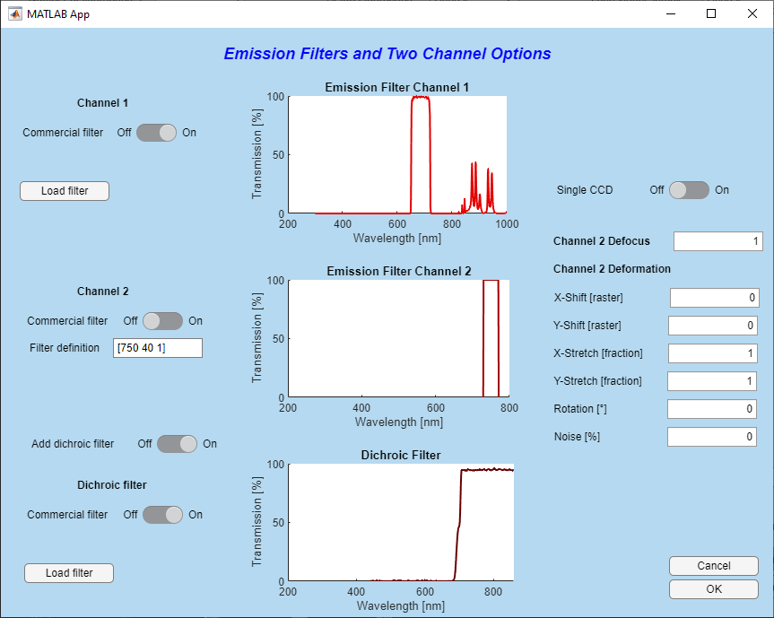Alternatively you can also import a commercial filter, using text file format downloaded from e.g. Chroma <https://www.chroma.com/> or Semrock <https://www.semrock.com/>. The text file can have a header and should look like for example this:   
     
     
   When importing a commercial filter, you will get something like this:   
     
   When you click on *Load filter*, by default you are directed to the (relatively small) database of filters already available in SMIS.  
     
   The rest of the window only appears in dual channel mode. You can set this mode in the main SMIS window using « *Number of acquisition channels* ».   
   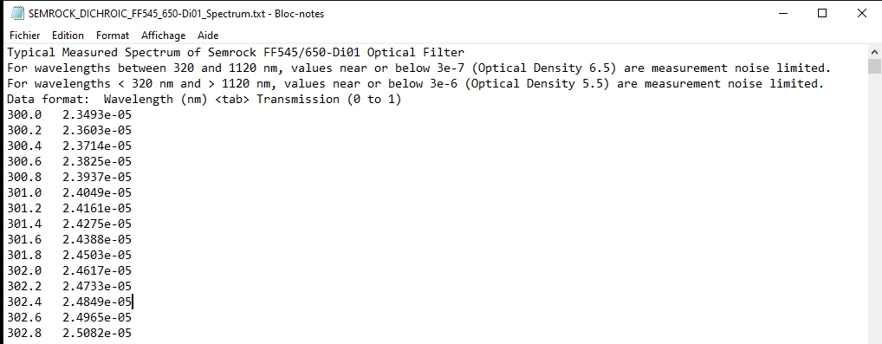
3. Similarly as for Channel 1, enter filter definition for Channel 2
4. You can optionally also enter a dichroic filter.
5. If a dichroic filter is chosen, similarly as for the emission filters, this can be based on a Matlab formula or on importing a commercial filter. When using a Matlab formula, use e.g. [600 10 0.1 0.9] where 600 nm is the cutoff wavelength, 10 nm is the transition bandpass, 0.1 is the low-pass transmission and 0.9 is the long-pass transmission.
6. For multichannel experiments, you can simulate either a 2-camera mode (« *Single CCD* » set to *off*) or a single-camera mode (« *Single CCD* » set to *on*). In the former case two *.tif* stacks will be produced, one for each camera, and in the latter case a single *.tif* stack will be produced where the images of the two channels are adjacent (equivalent of “split view”).
7. The two channels may not be both perfectly in focus. Set here the defocus of the second channel relative to the first. The PSF width will be multiplied by the entered value in the second channel.   
   This is however only valid currently for 2D simulations.
8. To simulate effects such as chromatic aberration, the second channel might be deformed relative to the first, through X and Y shift, X and Y stretch, and image rotation. A certain amount of noise in these deformations can be introduced.

# Setting up the EMCCD camera

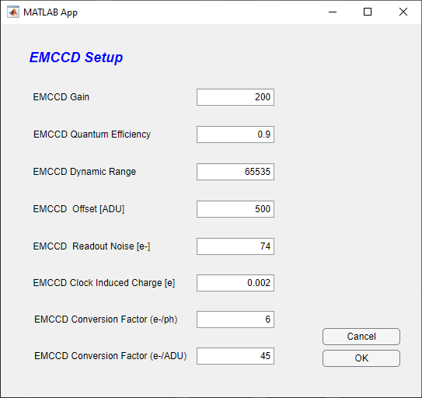Upon selecting « *EMCCD camera*» in the main SMIS window, the following window will appear:

**3**

**4**

**5**

**6**

**7**

**8**

**2**

**1**

1. Define here the EMCCD gain : the signal (and clock induced charge noise) will be amplified by this factor before detector readout.
2. Define here the EMCCD quantum efficiency. If for example set to 0.9, only 90% of the photons will be detected.
3. Define here the EMCCD dynamic range (typically 16 bits)
4. Define here the EMCCD offset (number of ADU’s recorded per pixel in the absence of any signal)
5. Define here the EMCCD readout noise in electrons : this is the electronic noise that is induced by the reading of the detector (independent of EMCCD gain).
6. Define here the EMCCD clock induced charge in electrons. This is an electronic noise in CCD detectors that adds up to the input signal and that will be amplified together with it depending on the set EMCCD gain
7. Define here the EMCCD conversion from photons to electrons (ie : number of electrons produced by one photon)
8. Define here the EMCCD conversion factor from electrons to ADU (ie : number of electrons to produce one ADU).

If you use Thunderstorm to process the data, you will need to set up the camera parameters according to the parameters above.   
Note that in thunderstorm the parameter named “*photoelectrons per A/D counts”*  
 corresponds in SMIS to the ratio “*EMCCD conversion factor (e-/ADU)*” divided by “*EMCCD conversion factor (e-/ph)*”, giving in fact an EMCCD conversion factor in (ph/ADU) which is abusively named *photoelectrons* *per A/D counts* in Thunderstorm*.*

# Setting up the fluorescence background

Upon selecting « *Fluorescence background* » in the main SMIS window, the following window will appear:

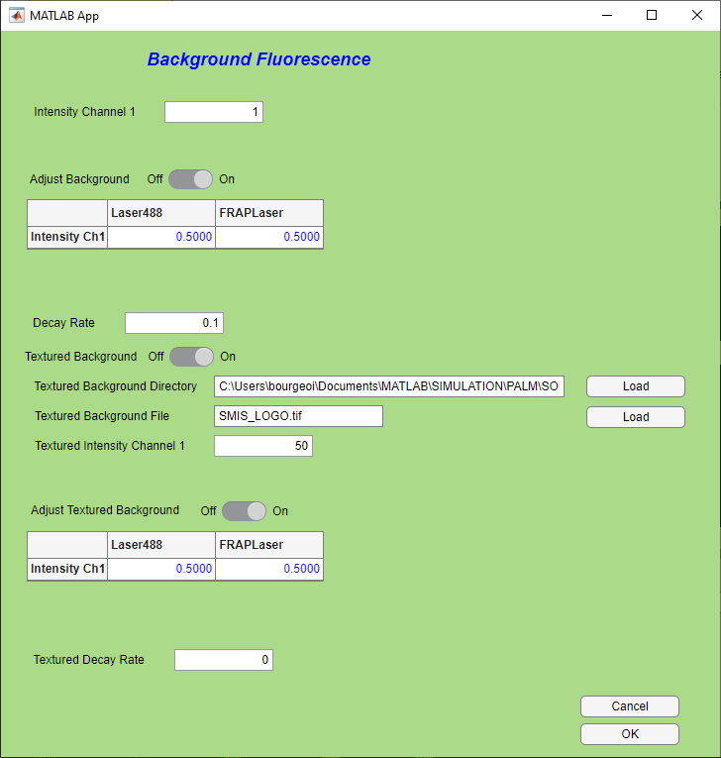

**4**

**5**

**6**

**2**

**3**

**1**

1. Define the background Intensity in Channel 1. The unit is [photons/100x100nm²/100W/cm²/s], so that the background is given per unit area and is sensitive to laser power and time. Thus, if you change laser power or e.g. frame time, the background will be changed accordingly.
2. Moreover, you can adjust the background according to local laser power density, ie e.g. for a Gaussian laser beam, you will have more background at the center of the images. Furthermore, you can adjust how background depend on the different lasers that you are using, putting more weight for example on green lasers than red lasers.
3. The background may bleach over time, which is usually the case. The decay rate is specified in [uJ/100x100nm²/s], so it also depends on employed laser powers.
4. In addition to the homogeneous background, you can define a background pattern in SMIS, according to a specific image, which is usually the same as the virtual sample in 2D or a z-projection of the virtual sample in 3D. If you select this option, enter the directory file name and intensity of the textured background in the same unit as above: [photons/100x100nm²/100W/cm²/s]. Note however that if the image used for textured background has several pattern IDs (ie pixel values > 0), the textured background will be applied to all pattern IDs in the same way.
5. Similarly as in 2., you can adjust the textured background according to local laser intensity
6. Similarly as in 3., you can set a decay rate for the textured background

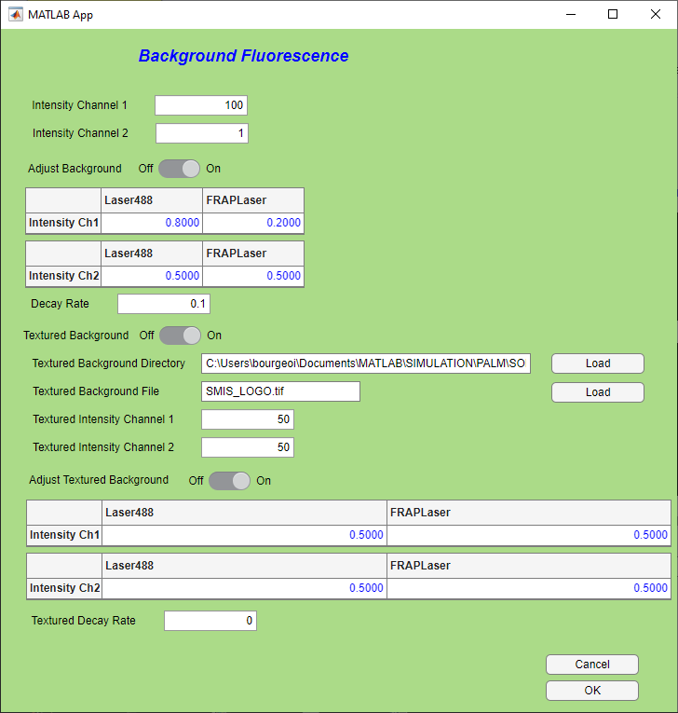All these features are duplicated in the case of a 2-channel experiment:

# Setting up sample drift

Upon setting « *Sample drift*» to *On* in the main SMIS window, you can enable sample drift during data acquisition. Then, by pressing on « *Edit drift*», the following window will appear:

You can set translational drift in the X and Y dimensions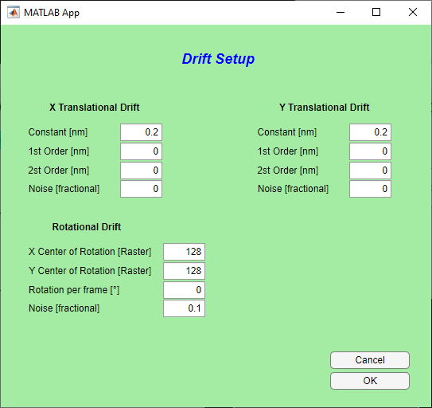, and in the Z dimension for 3D simulations. For each dimension, you can define a constant, a 1st-order and a 2nd-order drift per frame. Some noise can be added, as a fraction of pixel size. The formula to calculate the drift *d* is then:

$d \left[nm\right]=Constant+\frac{fn}{N}×1st order+{\left(\frac{fn}{N}\right)}^{2}×2nd order+Noise/pixelsize$

With *fn* the frame number and *N* the number of frames in the simulation.

Rotational drift can also be added in the X and Y plane: you can define a center of rotation, a rotation per frame and some noise.

*******It is not advisable to set any drift in sptPALM experiments, as the drift will make molecules move but not the virtual samples, so that confinement and exchange between diffusion states might be corrupted.*

**Tip: You can use drift artificially, for example to scan the sample in Z when you want to calibrate the PSF for 3D astigmatism.**

# Fluorescence sampling rate

Upon selecting « Fluorescence sampling rate» in the main SMIS window, the following window will appear.

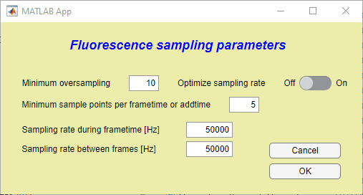

**4**

**5**

**2**

**1**

**3**

1. Minimum oversampling of fluorescence photophysical states relative to the maximum transformation rate experienced by the fluorophores. By default, a value of 10 is set, but this can be decreased down to 2 or 1 in case of very long simulation times, and depending on the goal of the simulation.
2. On the other hand, even if photophysical states change really, you want to set the minimum number of sampling points per frametime or in between frames.
3. The effective sampling rate can be be optimized to match the specified minimum oversampling and minimum sample points per frametime or addtime. **This is in general advisable**.
4. In case optimization of sampling rates is not chosen, the sampling rate during frametime can be entered manually. Note that the input sampling rate might be raised automatically by SMIS if imposed by the calculated photophysical transformation rates. However SMIS will not lower the entered rate.
5. Same for the sampling rate during addtime.

**Proper setting of the fluorescence sampling rate can drastically affect simulation time. A too high sampling rate may not be useful and will slowdown computing, whereas a low sampling rate may affect accuracy.**

# Other general parameters

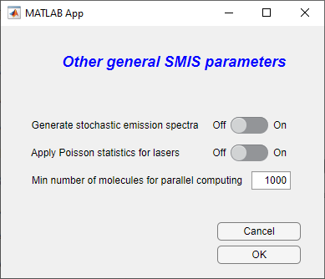Upon selecting « *Other general parameters*» in the main SMIS window, the following window will appear:

**3**

**2**

**1**

1. If this option is turned on, stochastic emission spectra will be calculated for each non-bleached molecule at every frame. For a high number of emitted photons, these spectra will resemble the ensemble emission spectrum of the fluorophore input in the fluorophore definition. This option generates a lot of data and should not be used for simulations involving many molecules and/or many frames.
2. If this option is turned on, the number of photons absorbed by the single molecules upon laser illumination will be Poisson-distributed instead of calculated in a deterministic manner. As usually this number is quite high, this is really useful, but it might be considered in case of very low illumination regimes.
3. This is the minimum number of molecules required to allow turning on parallel computing: below this number, even if parallel computing is set on, it will be turned off because it will be very inefficient. During a simulation starting with a high number of molecules, when the number of unbleached molecules will become below the entered minimum number, parallel computing will be automatically switched off.